

# *UniX and Linux Essentials*

**ASSIGNMENT - 5**

**SUBMITTED BY:**

**AYUSH KUMAR JHA**

**SAP ID - 500086400**

**Enrollment no - R200220083**

**B.C.A -I.O.T. -FIRST YEAR**

**Assignment 5: -**

**Link files:-**

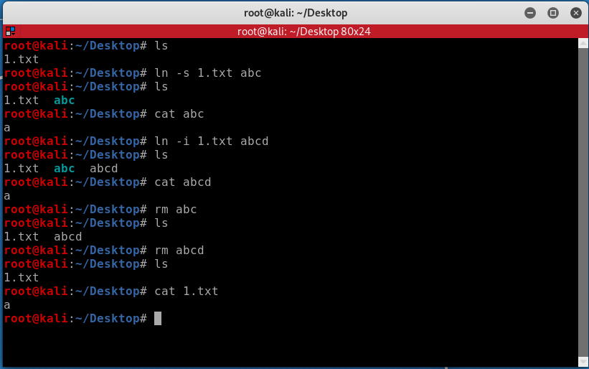

**Coping Command: -**

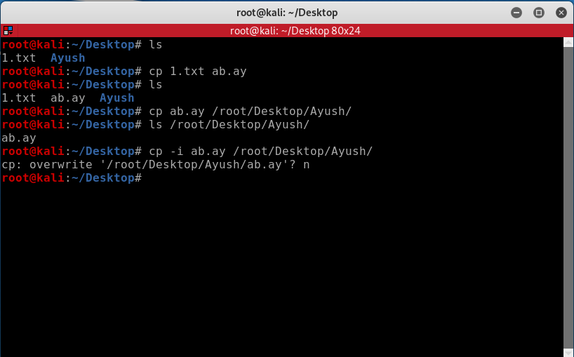

**Moving Files:-**

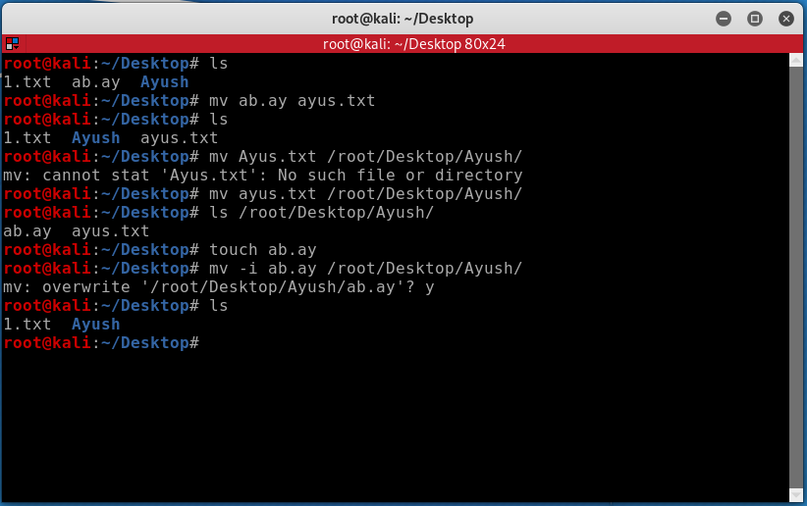

**Directory:-**

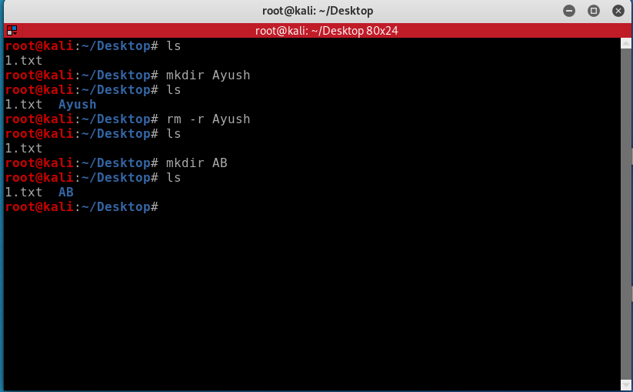

**Search:-**

